Experiment No.: 1
Title: Demonstrate inline, internal, and external JavaScript; use console methods; create a webpage showing user info and a welcome message.
Software/Tools Required: HTML5 , CSS3 , JavaScript , Visual Studio Code , Google Chrome
Theory: JavaScript is a client-side scripting language used to make web pages interactive and dynamic. It can be included in a webpage using inline, internal, or external scripting methods. JavaScript performs operations, manipulates HTML elements through the DOM (Document Object Model), and responds to user actions. Console methods such as console.log(), console.warn(), and console.error() help in debugging and testing code. In this experiment, JavaScript is used to display user information, show a welcome message, and demonstrate different scripting techniques.

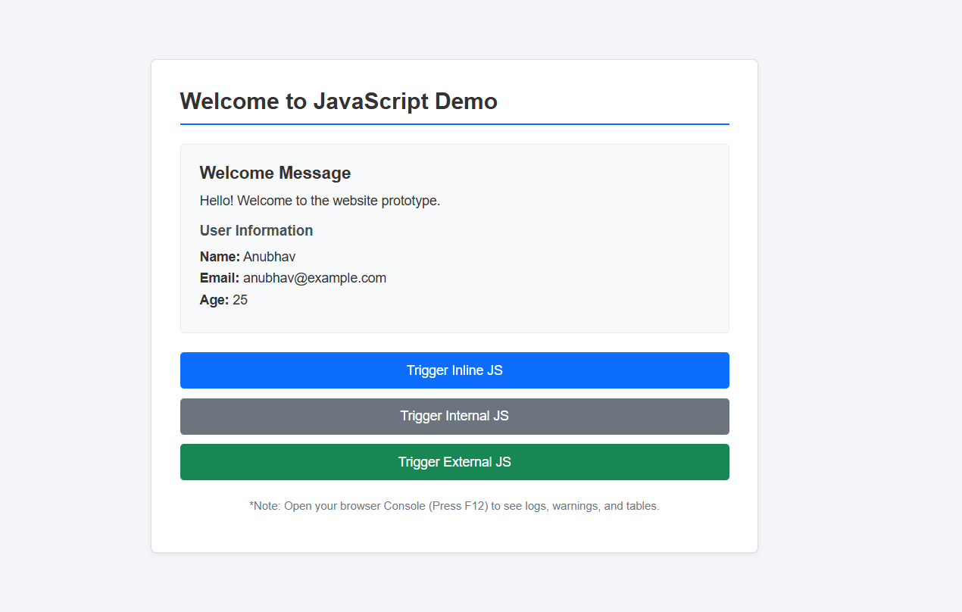

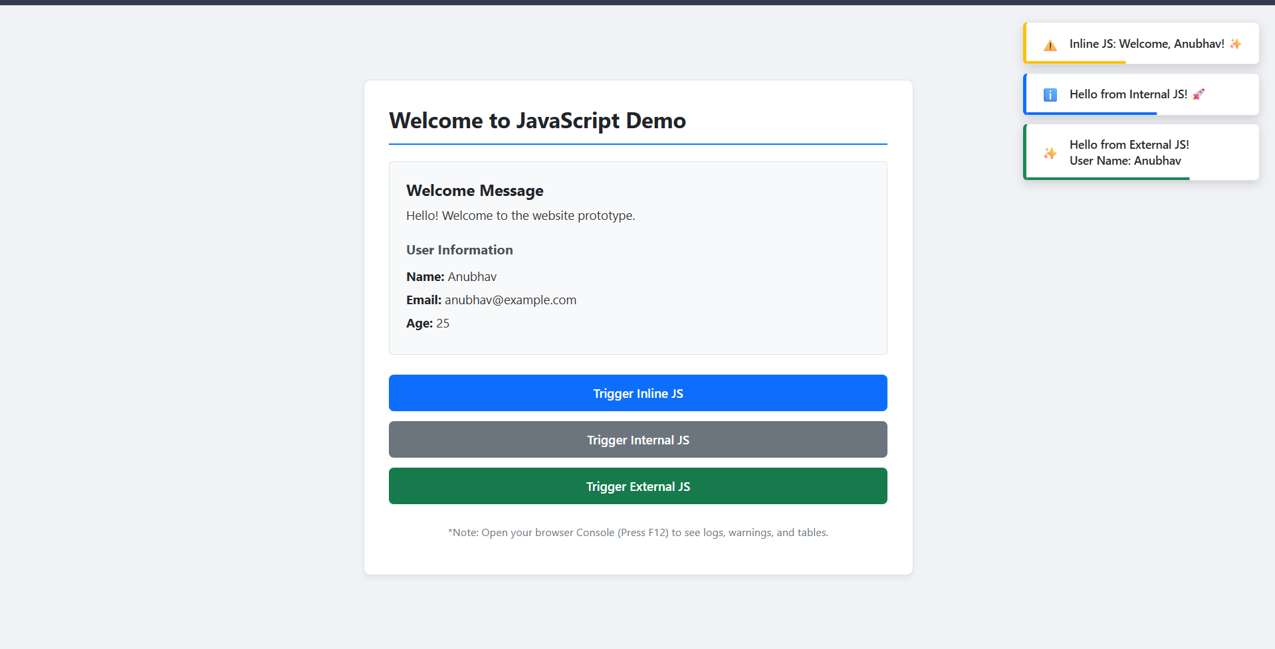

Result: The webpage was successfully created using HTML, CSS, and JavaScript. It demonstrated inline, internal, and external JavaScript, displayed user information with a welcome message, and showed various console methods in the browser console.
Conclusion: The experiment helped in understanding the different ways of including JavaScript in a webpage and how it interacts with HTML elements. It also demonstrated the use of console methods for debugging and basic DOM manipulation.

